Switched Mode DC-DC Power Converters (Basic Topologies)

CIRCUIT DIAGRAM and CALCULATIONS:

Problem 1: Theoretical solution

Problem 1: Simulated circuit with graphs

|

|

|

|

Problem 3: Theoretical solution

Problem 3: Simulated circuit with graphs EXPERIMENT NO: 9 DATE: / / 2022

# Switched Mode DC-DC Power Converters (Basic Topologies)

AIM: To Design Switched Mode DC-DC Power Converters (Buck, Boost, Buck-boost) and verify it through simulation.

APPARATUS AND COMPONENTS REQUIRED: Sequel Simulator

THEORY: Write theory related with following questions:

1. What is need of SMPS Vs. linear? State their applications
2. What is operating principles of Buck, Boost and Buck-Boost PWM DC-DC Converters?
3. Obtain design equations for the design of inductor and capacitor in SMPS assuming ideal switches.

PROCEDURE:

1. Design the Buck, Boost and Buck-boost converter as per the specifications given in the problem statement.
2. Verify the design done in step 1) by simulation.

RESULT:

CONCLUSION:

______________________________________________________________________________

______________________________________________________________________________ __________________________________________________________________________

Design Problems to be solved:

(1) Design a Buck converter for converting a variable input DC in the range 36-72 Volts, to get a regulated output at 12V and 1A maximum. The switching frequency can be set at 50kHz. The maximum peak current ripple can be permissible up-to 10%. The maximum output voltage permissible ripple is 2%. Estimate the value of Inductor and the output filter capacitor. Find out the Duty cycle range for the input variation at 100% load. Verify the results by Computer simulation. Assume ideal switch and continuous conduction mode.

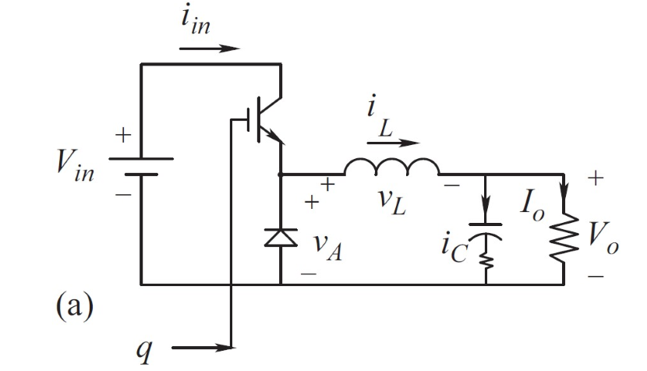

## BUCK CONVERTER

(2) Design a Boost converter for converting a variable input DC in the range 5 Volts, to get a regulated output at 12V at 3A maximum. The switching frequency can be set at 50kHz. The maximum peak current ripple can be permissible up-to 10%. The maximum output voltage permissible ripple is 2%. Estimate the value of Inductor and the output filter capacitor. Find out the Duty cycle range for the load variation from 10% to 100%. Verify the results by Computer simulation. Assume ideal switch and continuous conduction mode.

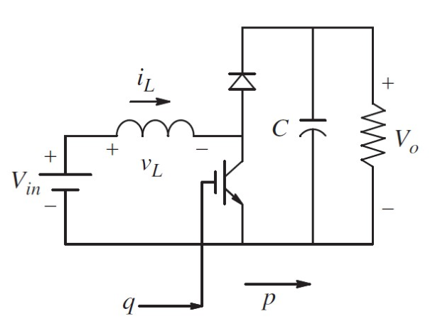

## BOOST CONVERTER

(3) Design a Buck-Boost converter for converting a variable input DC in the range 36-72 Volts, to get a regulated output at 48V at 2A maximum. The switching frequency can be set at 100kHz. The maximum peak current ripple can be permissible up-to 10%. The maximum output voltage permissible ripple is 2%. Estimate the value of Inductor and the output filter capacitor. Find out the Duty cycle range for the supply voltage variation at 50% load. Verify the results by Computer simulation. Assume ideal switch and continuous conduction mode.

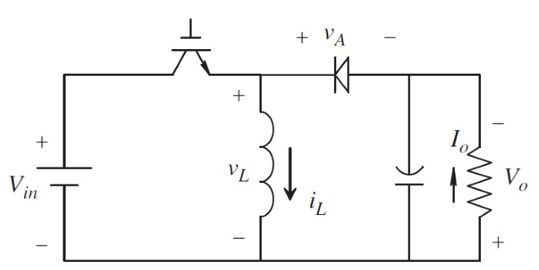

## BUCK-BOOST CONVERTER